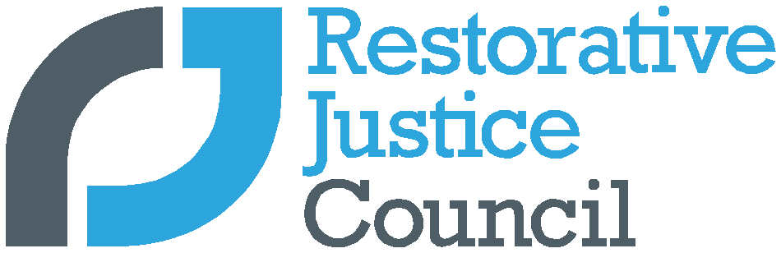
Lockdown Case Study
Submitted By:
Organisation:

As part of our #strongertogether campaign we want to showcase how practitioners have kept restorative justice going during the Covid-19 pandemic by publishing a series of ‘lockdown’ case studies. We invite you to submit your experience of practising during lockdown.
Submissions should be a minimum of 750 words and a maximum of 2,500 words
What has worked well for you?

What concerns have you had and how have you overcome these?

How have you utilised technology to support you work?

How have the participants you have worked with responded to remote working?

Free text
Consent to publication
Submitted By:
Email:
Telephone:
The Restorative Justice Council (RJC) would like to use your article / case study as an example of how restorative justice works and the way in which it can have a positive impact on people’s lives. We use articles and case studies in a number of ways to help spread the message. Before we can use your article / case study, you will need to provide consent.
How will my article / case study be used if I give my consent?
- We might use your article / case study (or extracts from it) in our newsletter, magazine, leaflets and on our website. We would ideally like a photograph to accompany your case study where possible.
- We might refer to your article / case study on a radio show or on TV.
- We might promote your article / case study on social media with links to the relevant area of our website.
- We might contact you to find out whether you would be happy to speak to a journalist or appear on a TV or radio programme. We will never give your contact details to a third party without asking your permission first.
If you have submitted a case study, we will also:
- Make sure you are sent a copy of your case study for your comments before we use it in any context. This is your story, and we want to get it right.
Anonymity: In exceptional circumstances we may be able to use your case study without using your real name - for example, if there are sensitivities around information you have provided.
Please indicate which of the following you agree to by deleting as necessary:
- I agree to my article / case study being used in RJC publications and communications and on the RJC website/s: YES NO
- I agree to my image being used in RJC publications and communications and on the RJC website/s: YES NO
- I agree to my real name being used in my story: YES NO
- I would like the RJC to contact me with requests from TV/radio/print journalists who would like to interview me: YES NO
- I understand that I can withdraw these permissions at any time but unless I do so, the RJC will continue to use my story in the ways described in this form: YES NO

Comments: Any other information that you feel we should know?
I agree and understand:
Name of the person giving consent
Date
Please note
If you are submitting a case study or an article which refers directly to a third party who could be identified in either the text or supporting image, you will need to submit an additional signed consent form for each individual.

